* Task 1: Create an Azure web app
* Task 2: Create a staging deployment slot
* Task 3: Configure web app deployment settings
* Task 4: Deploy code to the staging deployment slot
* Task 5: Swap the staging slots
* Task 6: Configure and test autoscaling of the Azure web app
* Task 1: Create an Azure web app

In the Azure portal, search for and select **App services**, and, on the **App Services** blade, click **+ Create**.

On the **Basics** tab of the **Create Web App** blade, specify the following settings (leave others with their default values):

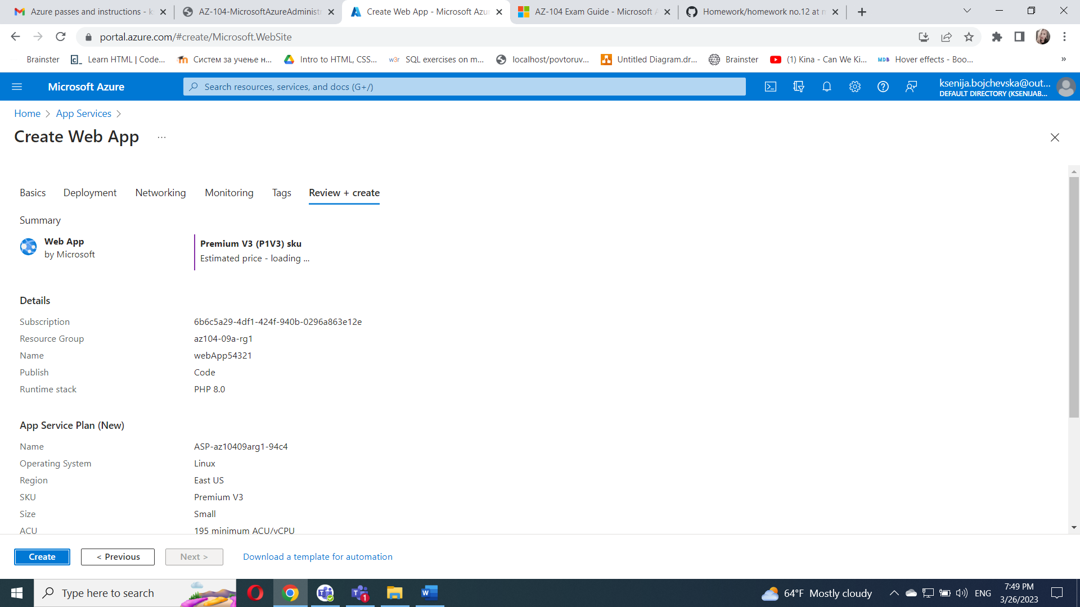

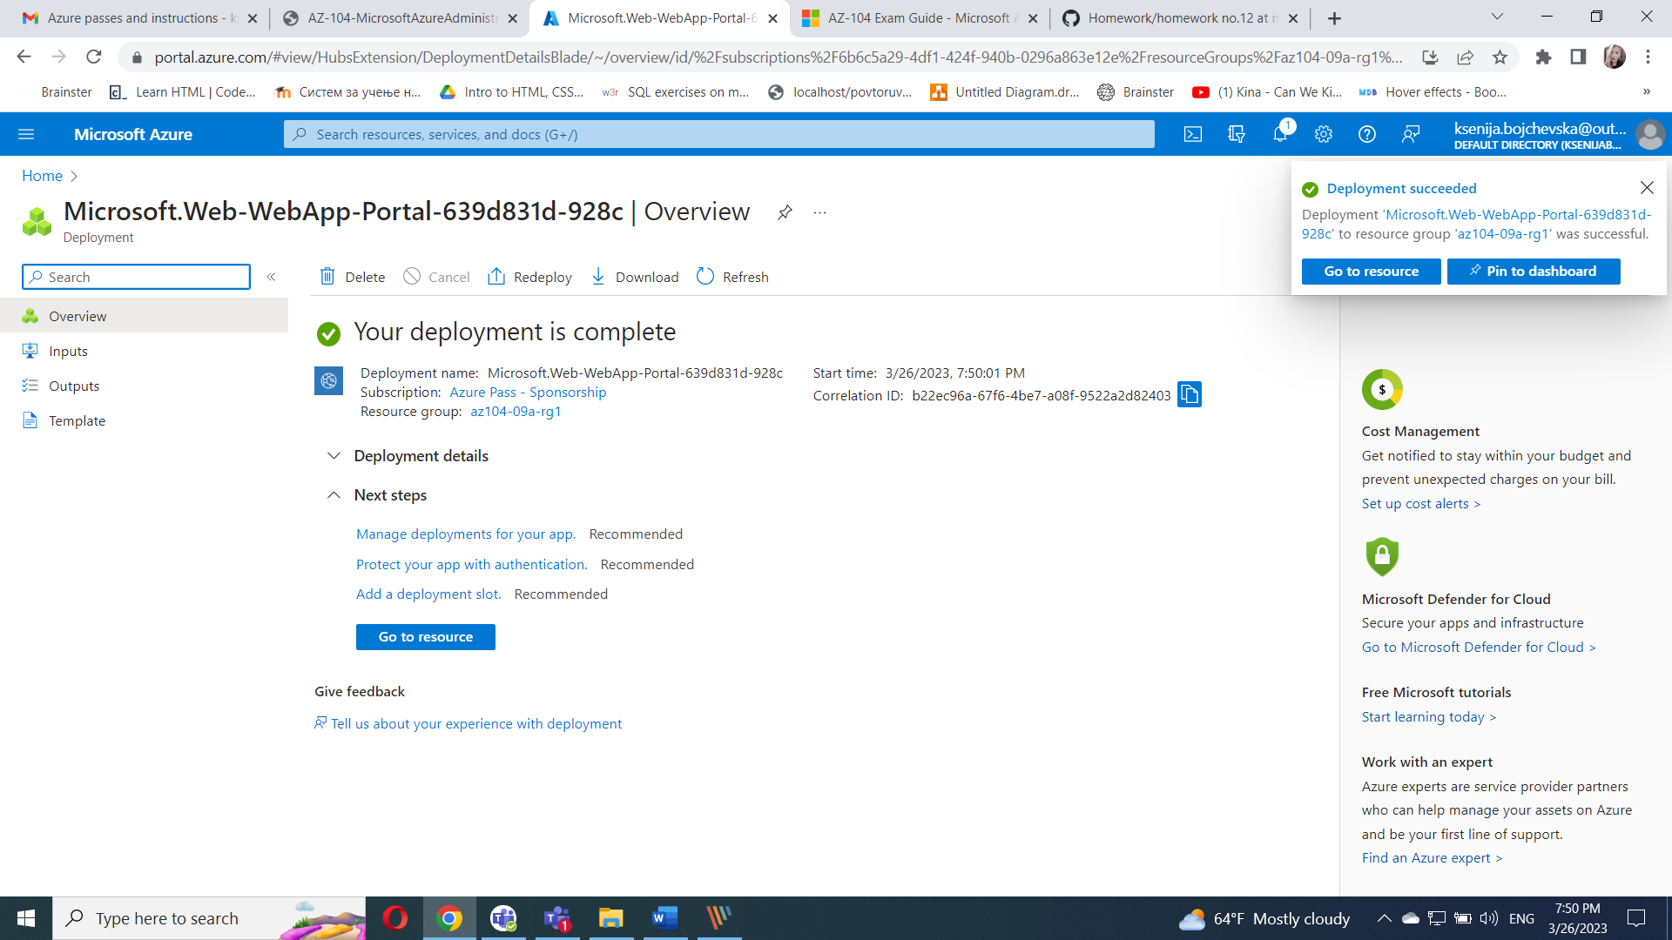

#### Task 2: Create a staging deployment slot

In this task, you will create a staging deployment slot.

On the blade of the newly deployed web app, click the **URL** link to display the default web page in a new browser tab.

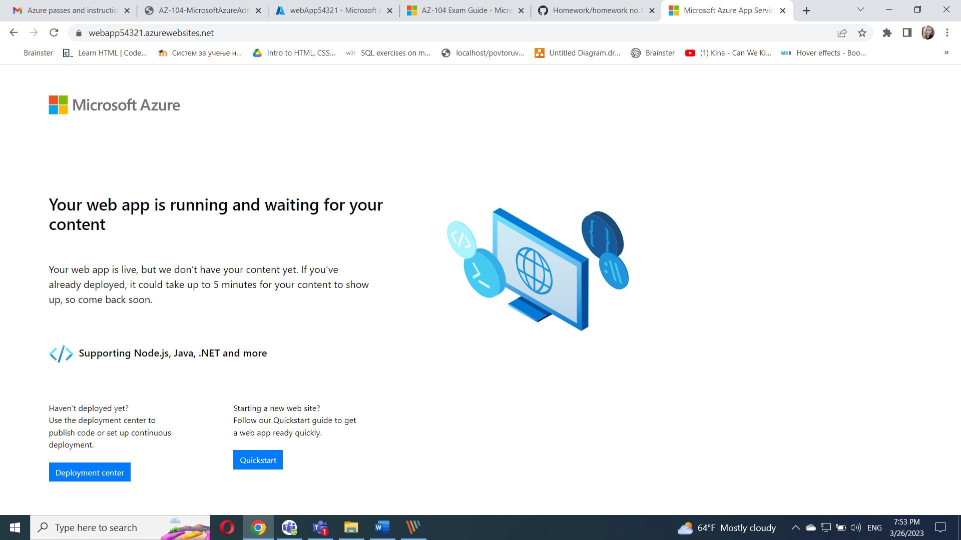

Close the new browser tab and, back in the Azure portal, in the **Deployment** section of the web app blade, click **Deployment slots**.

Click **+ Add slot**, and add a new slot with the following settings:

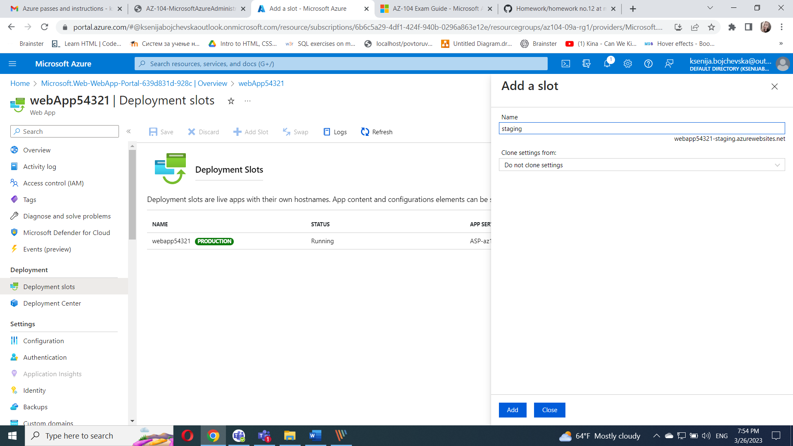

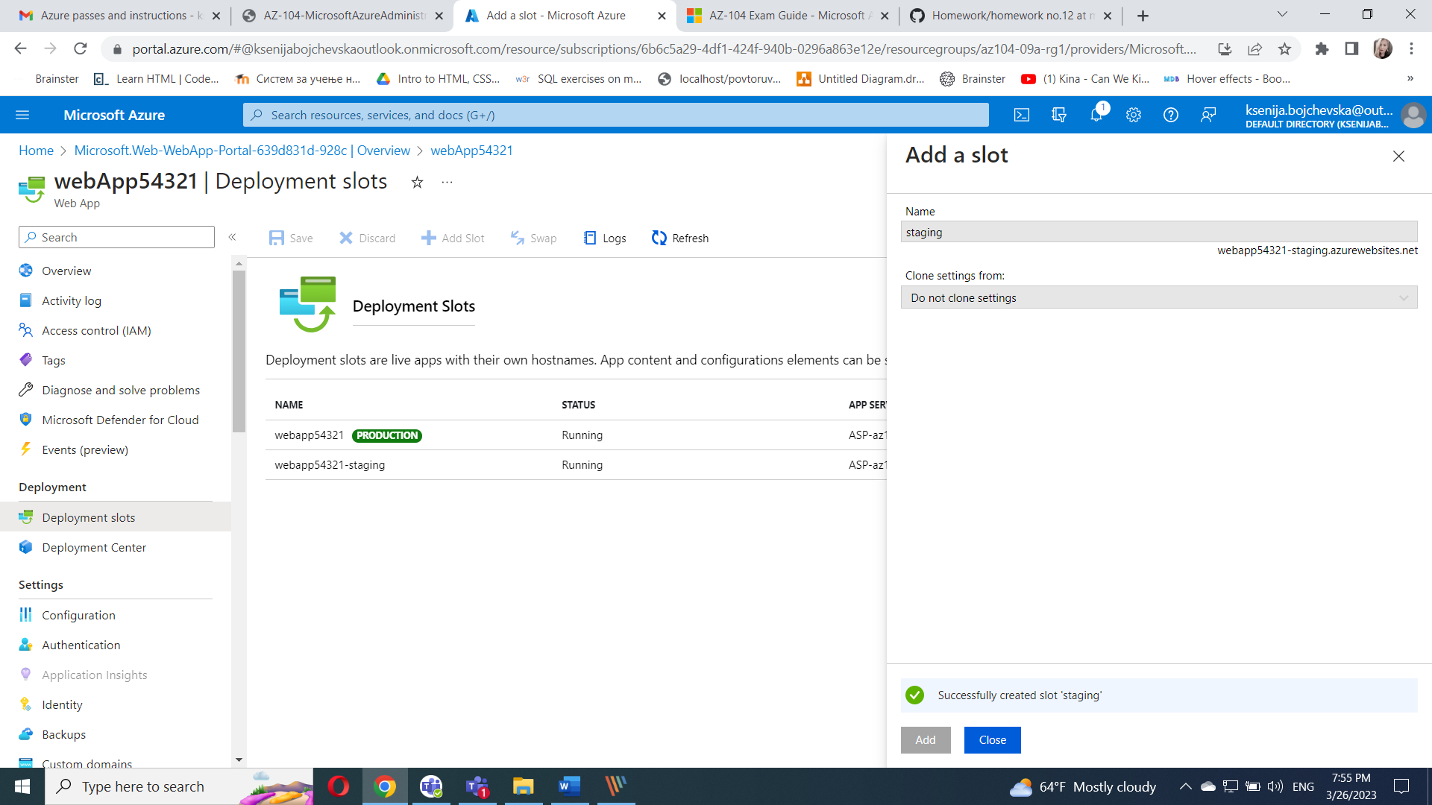

Back on the **Deployment slots** blade of the web app, click the entry representing the newly created staging slot.

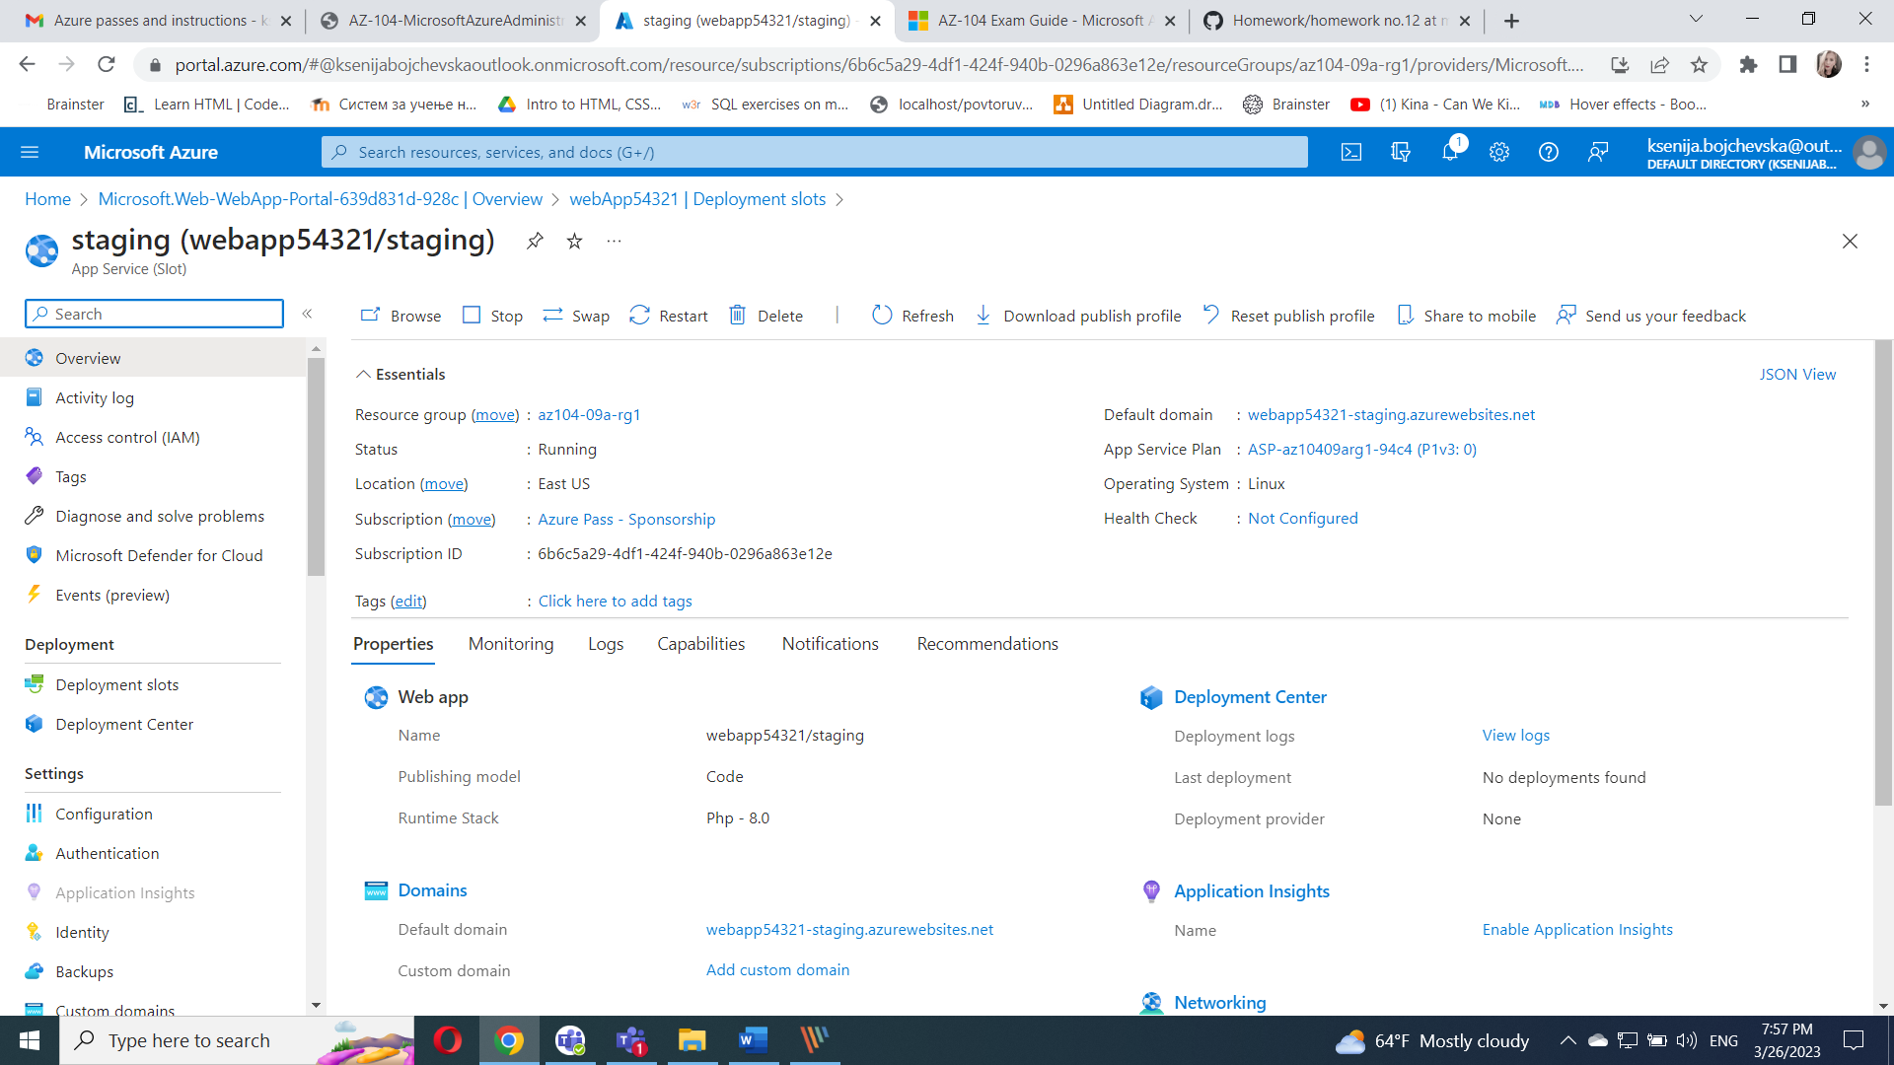

#### Task 3: Configure web app deployment settings

In this task, you will configure web app deployment settings.

On the staging deployment slot blade, in the **Deployment** section, click **Deployment Center** and then select the **Settings** tab.

On the **Settings** tab, in the **Source** drop-down list, select **Local Git** and click the **Save** button

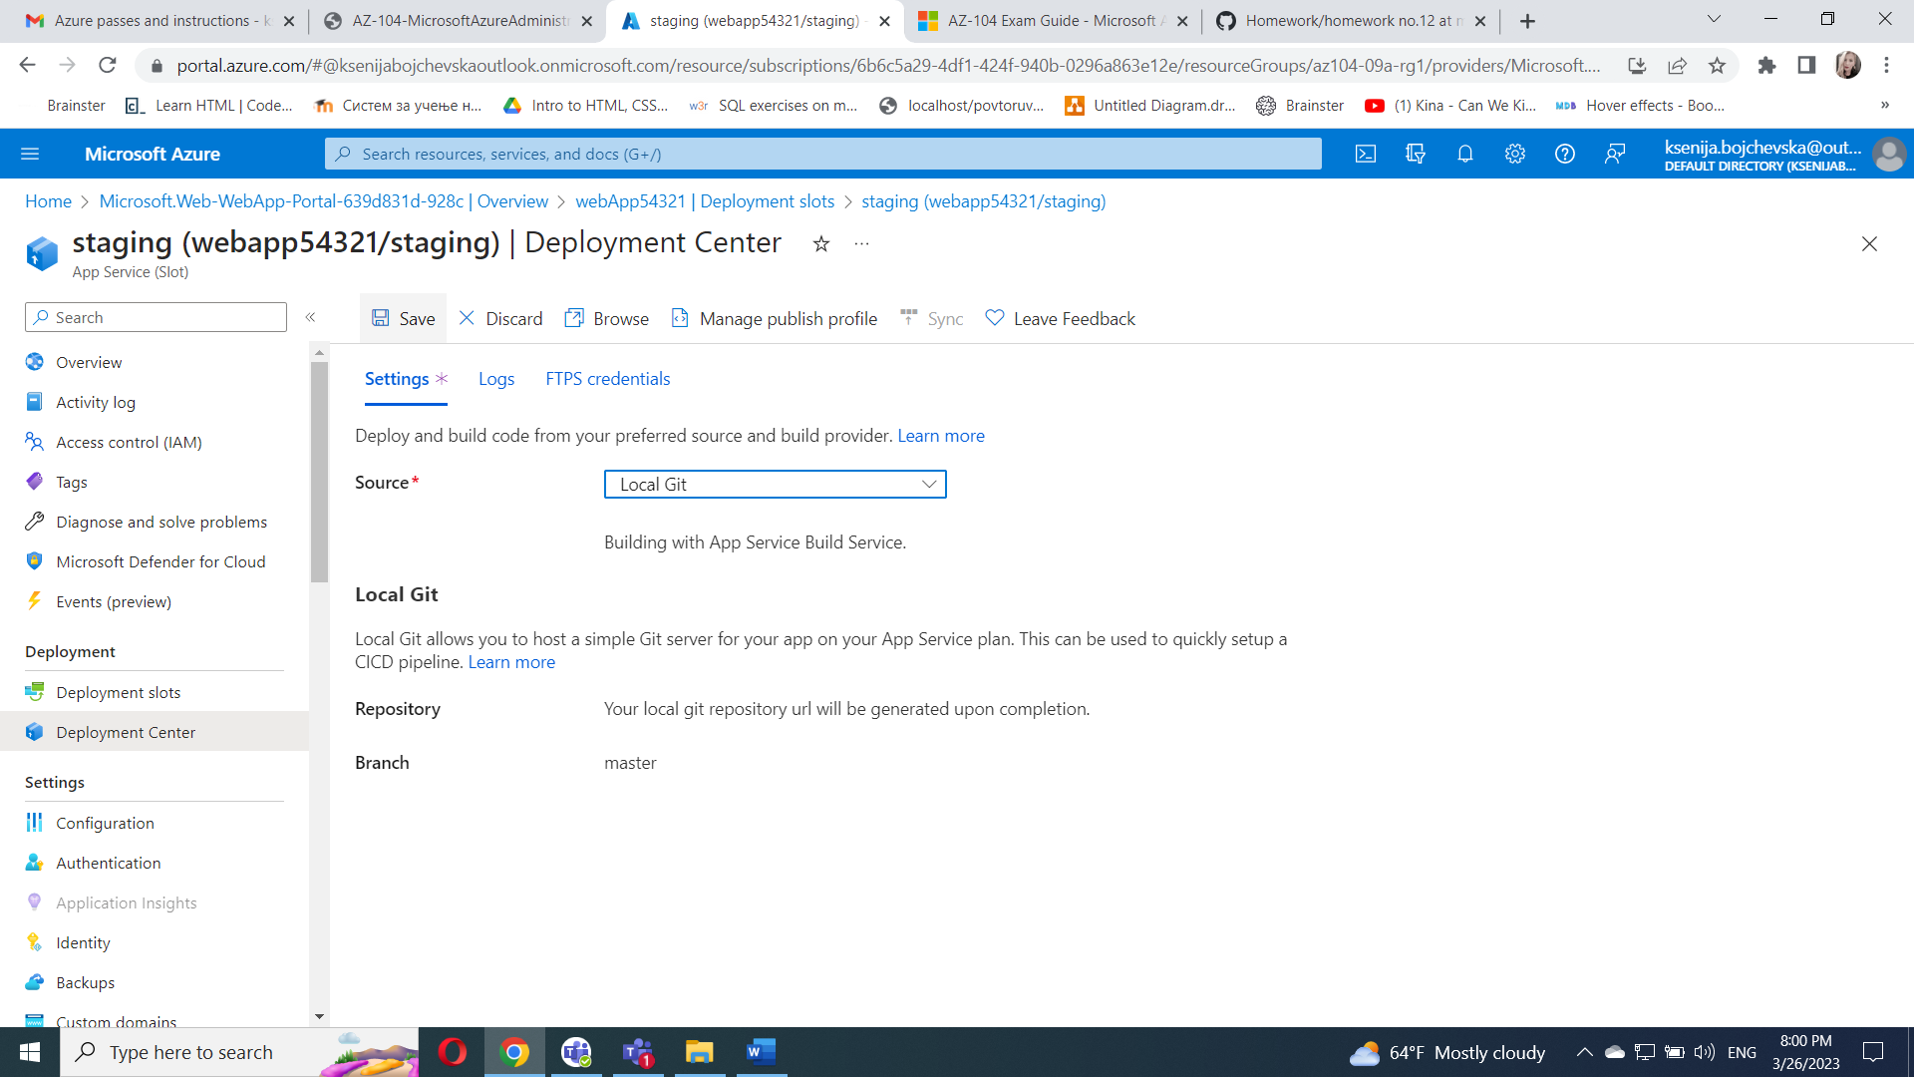

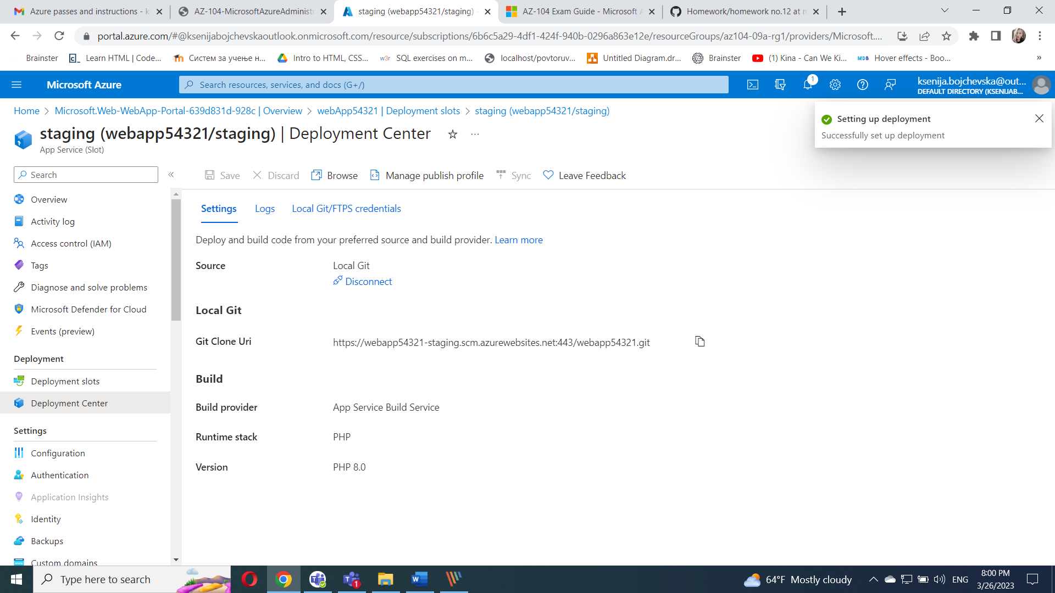

On the **Deployment Center** blade, copy the **Git Clone Url** entry to Notepad.

<https://webapp54321-staging.scm.azurewebsites.net:443/webapp54321.git>

On the **Deployment Center** blade, select the **Local Git/FTPS credentials** tab, in the **User Scope** section, specify the following settings, and click **Save**.

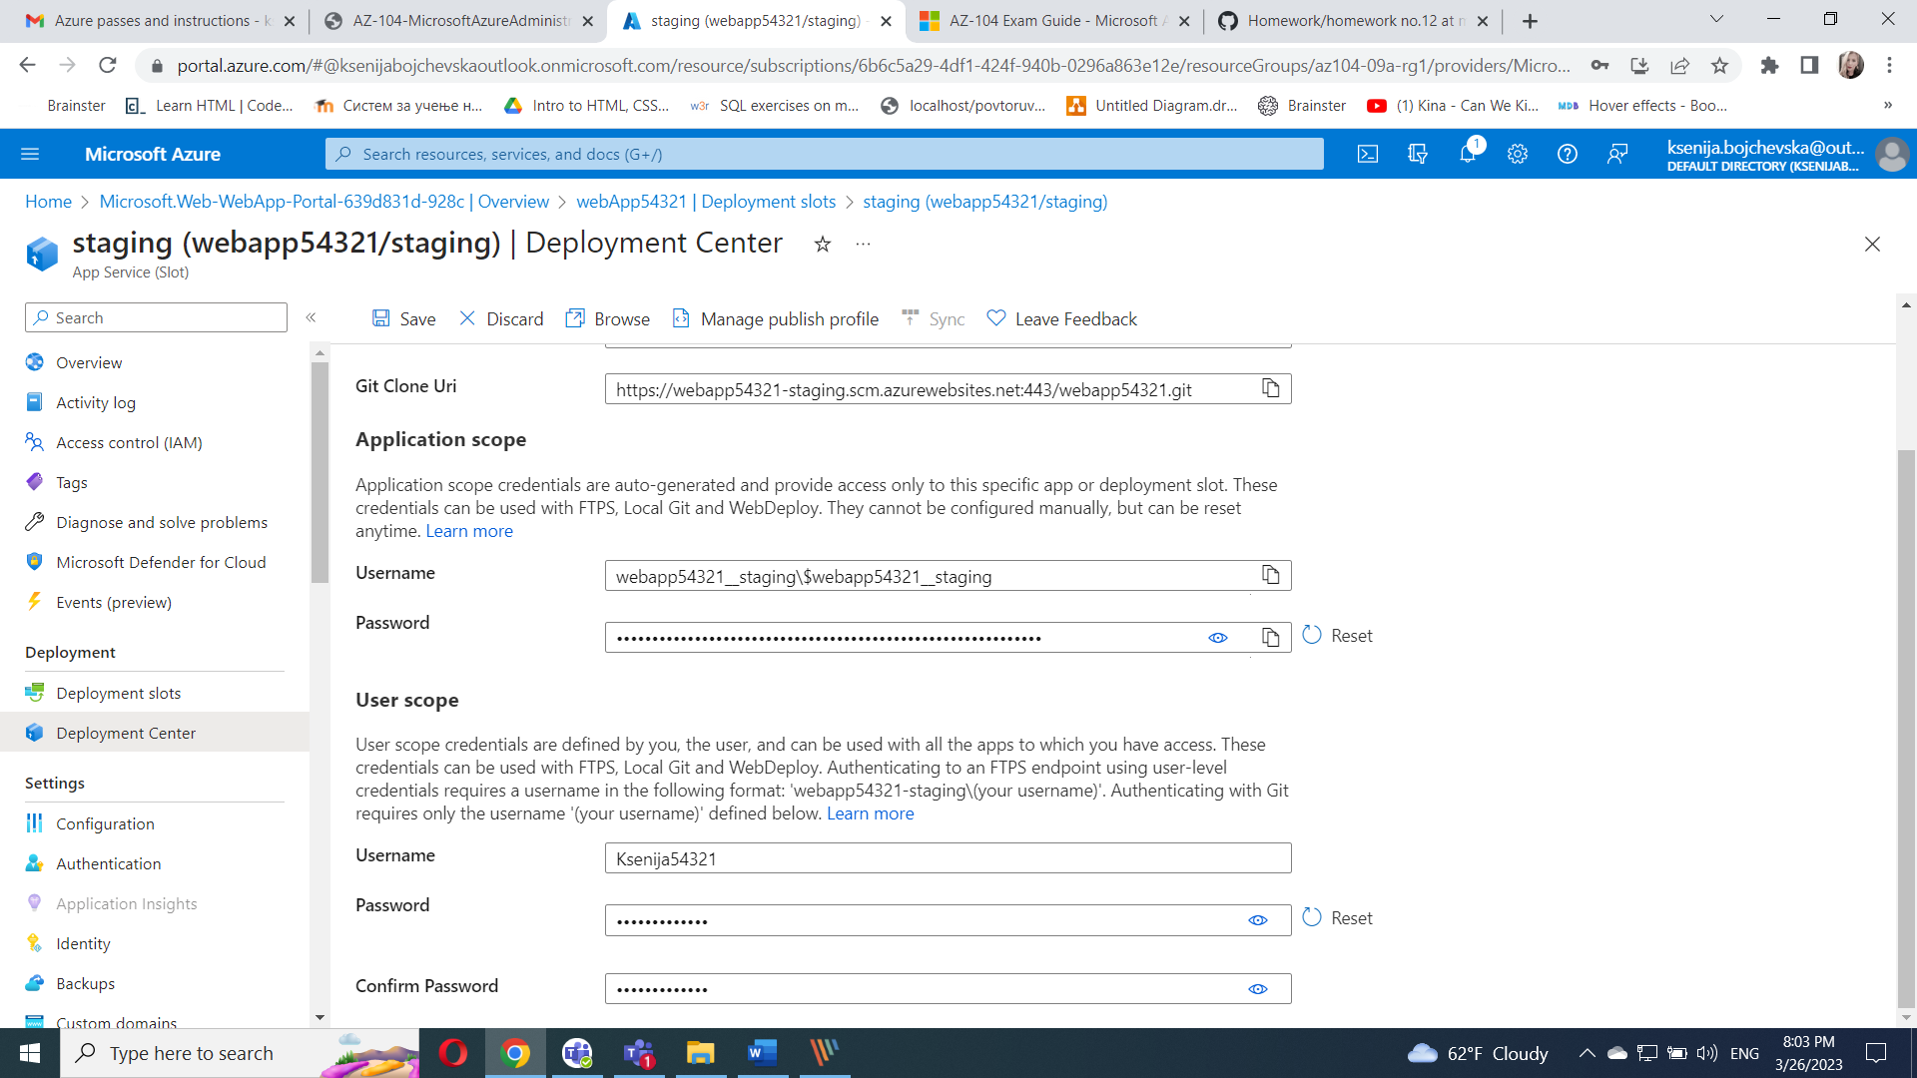

#### Task 4: Deploy code to the staging deployment slot

In this task, you will deploy code to the staging deployment slot.

In the Azure portal, open the **Azure Cloud Shell** by clicking on the icon in the top right of the Azure Portal.

If prompted to select either **Bash** or **PowerShell**, select **PowerShell**.

From the Cloud Shell pane, run the following to clone the remote repository containing the code for the web app.

git clone <https://github.com/Azure-Samples/php-docs-hello-world>

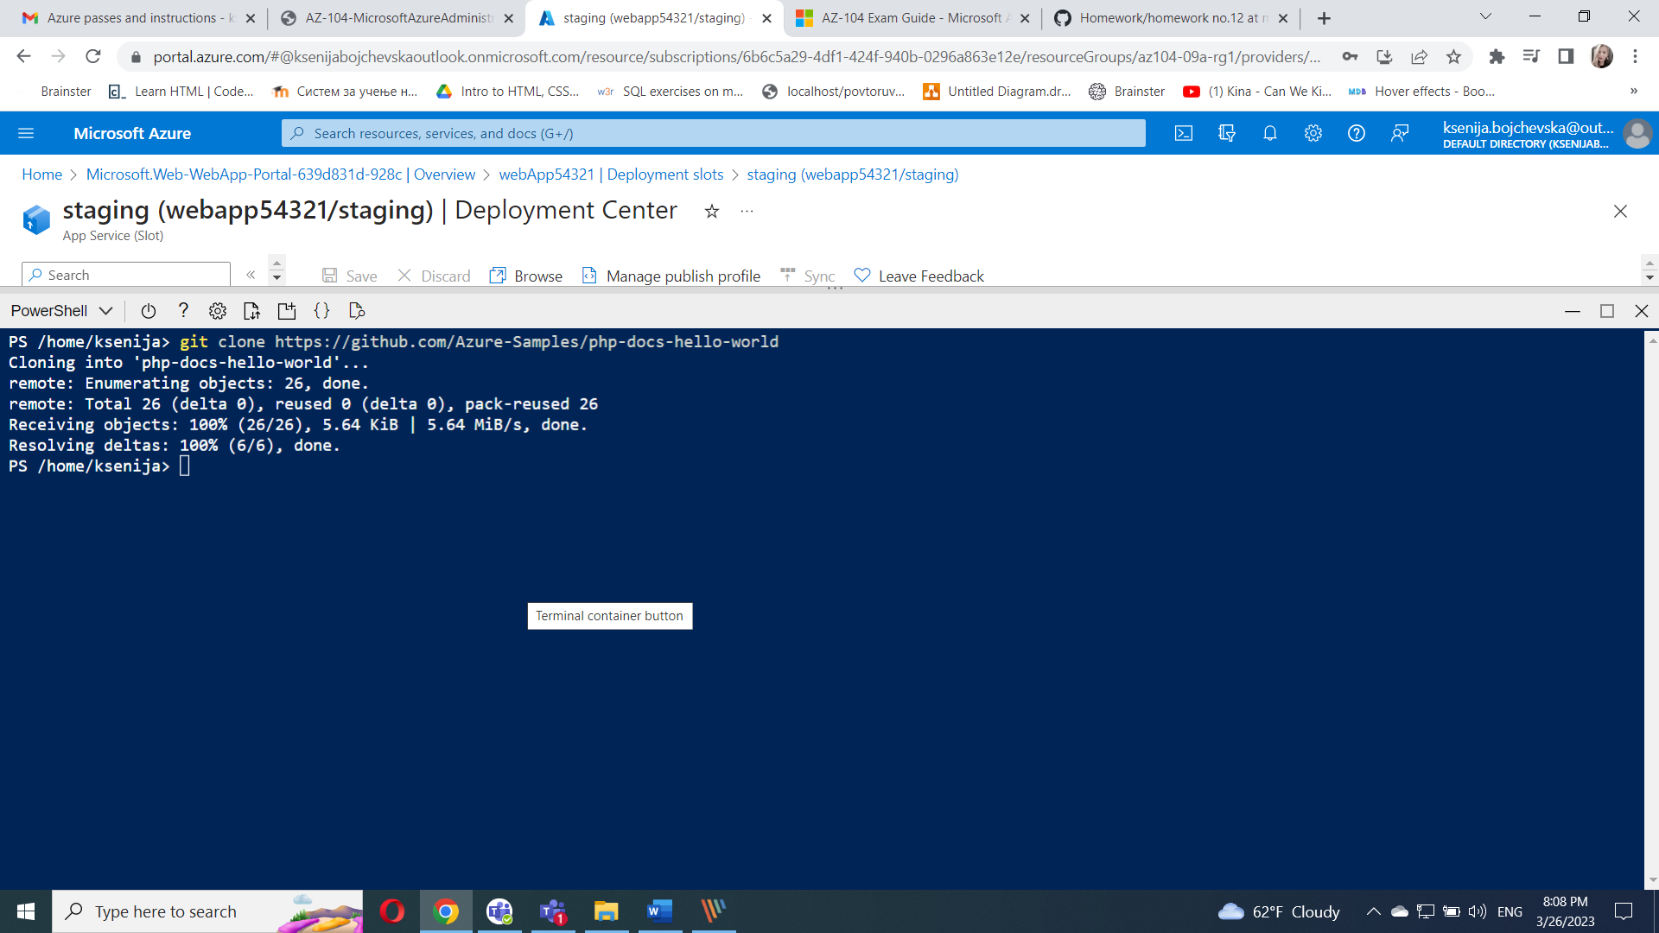

From the Cloud Shell pane, run the following to set the current location to the newly created clone of the local repository containing the sample web app code.

Set-Location -Path $HOME/php-docs-hello-world/

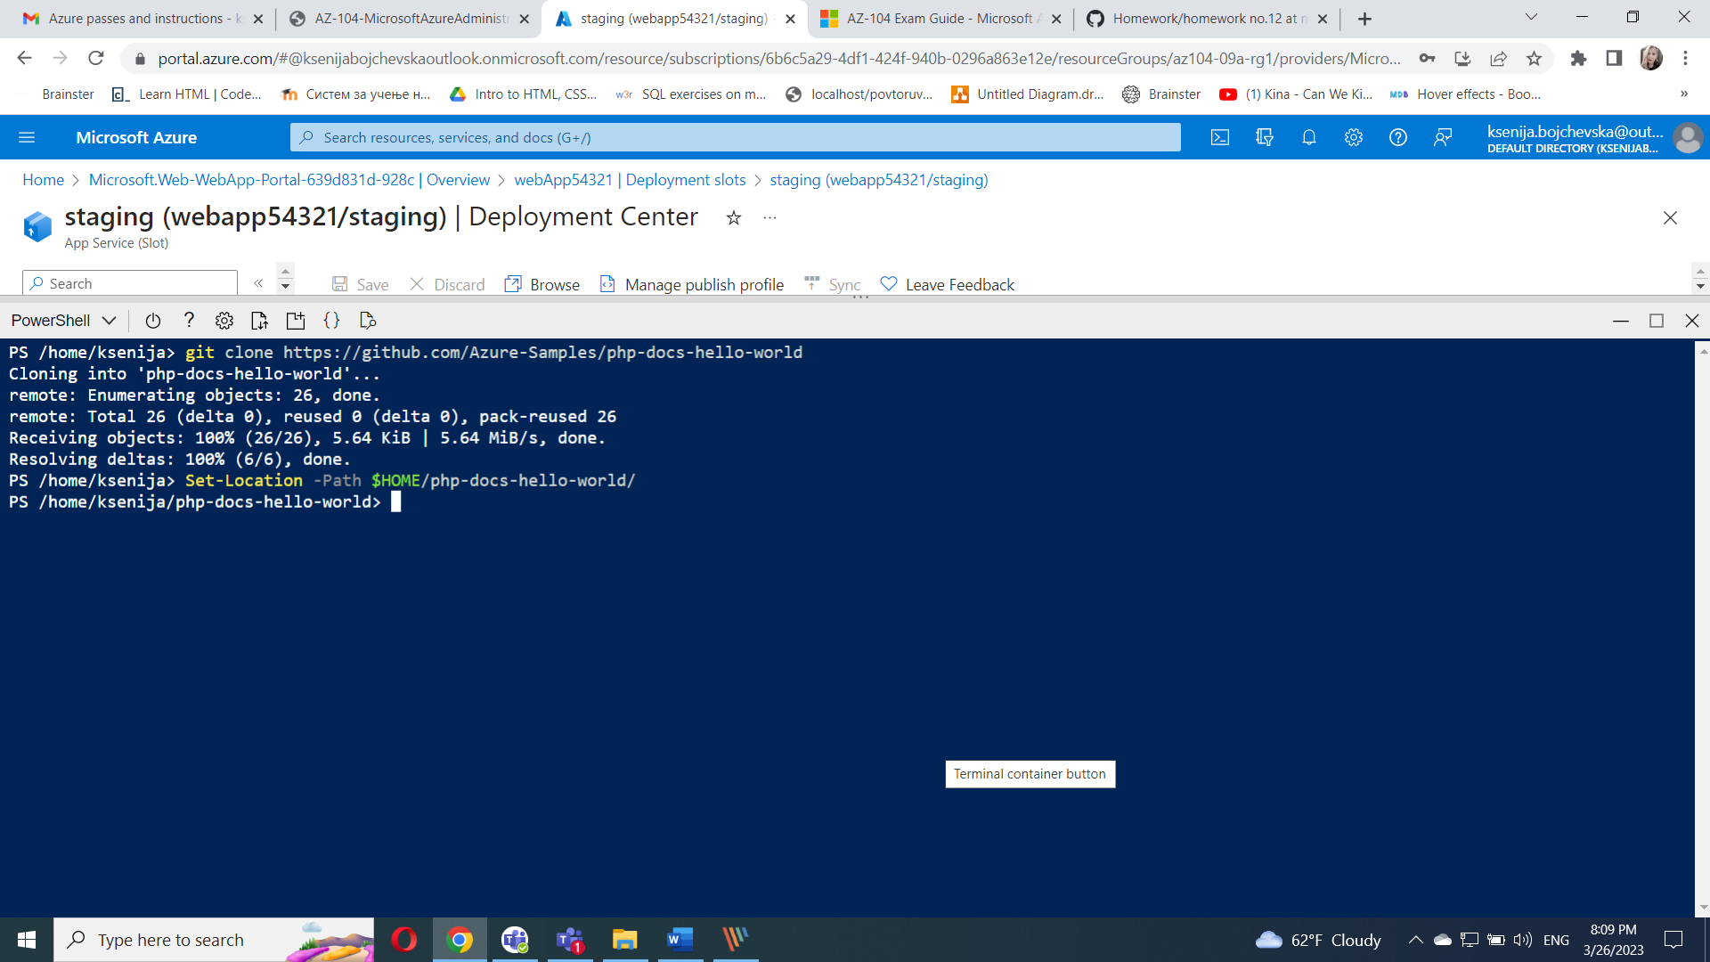

From the Cloud Shell pane, run the following to add the remote git (make sure to replace the [deployment_user_name] and [git_clone_url] placeholders with the value of the **Deployment Credentials** user name and **Git Clone Url**, respectively, which you identified in previous task):

git remote add [deployment_user_name] [git_clone_url]

git remote add Ksenija54321 <https://webapp54321-staging.scm.azurewebsites.net:443/webapp54321.git>

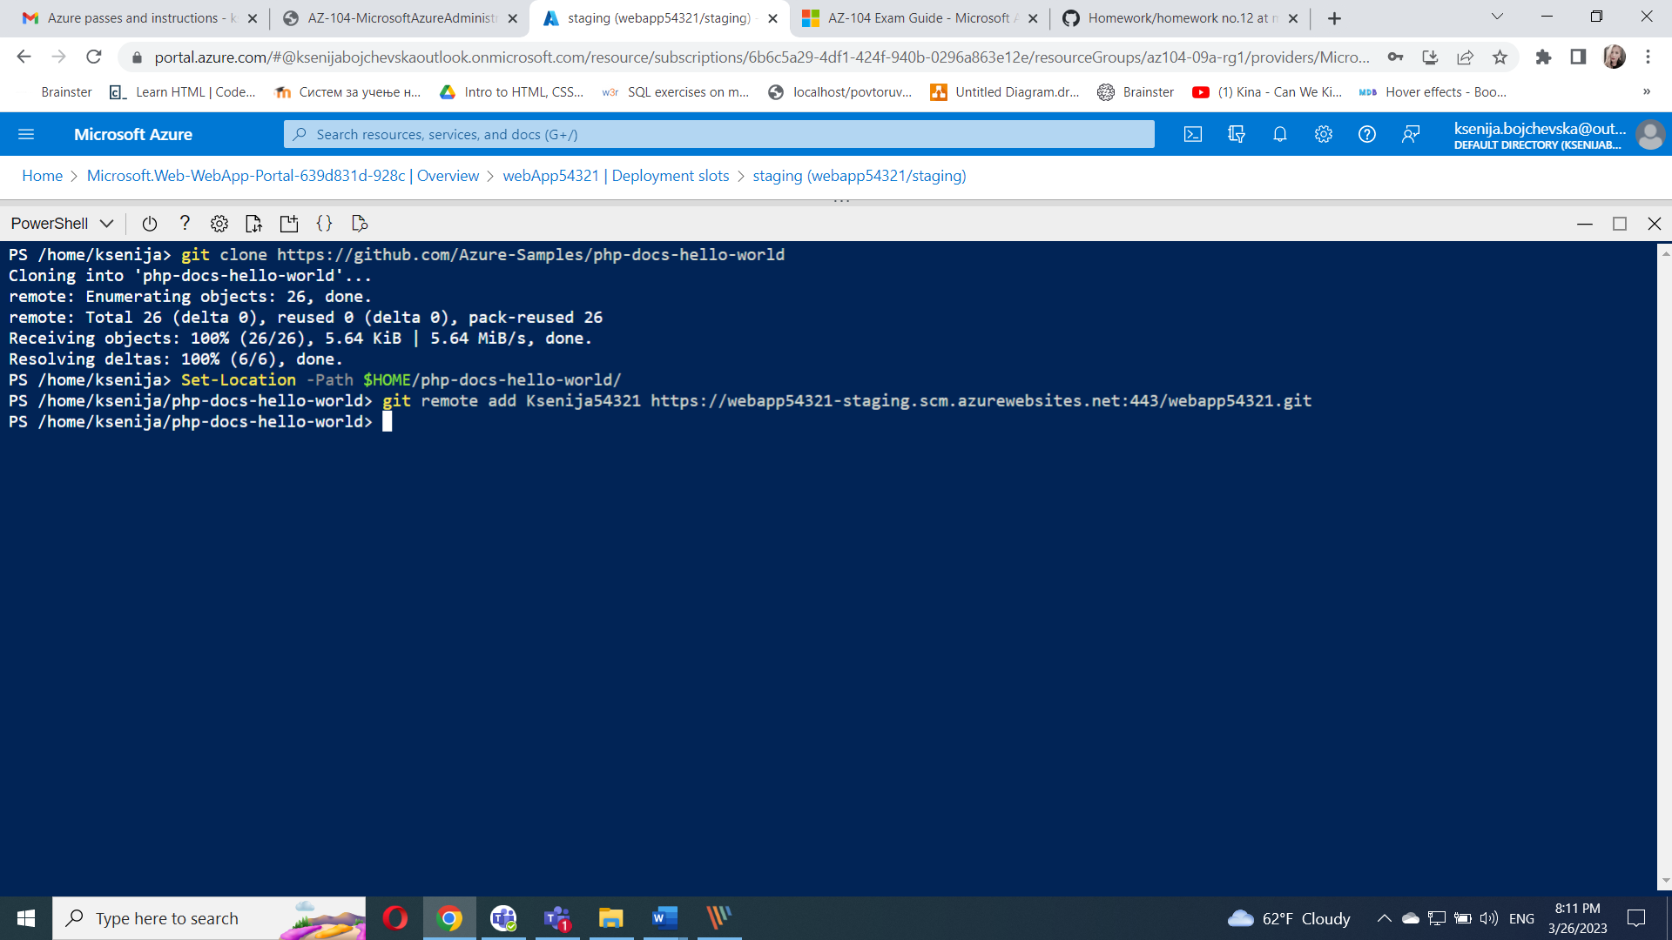

From the Cloud Shell pane, run the following to push the sample web app code from the local repository to the Azure web app staging deployment slot (make sure to replace the [deployment_user_name] placeholder with the value of the **Deployment Credentials** user name, which you identified in previous task):

git push [deployment_user_name] master

git push Ksenija54321 master

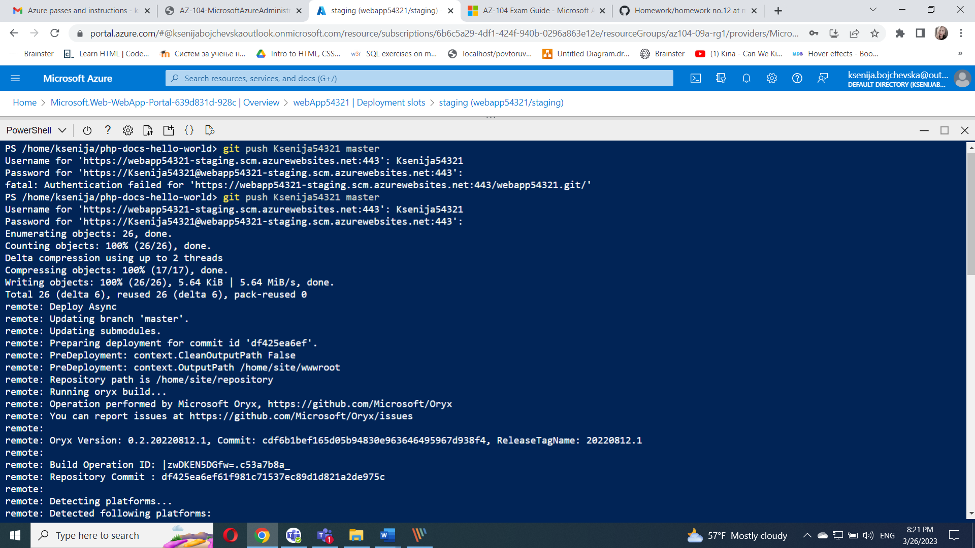

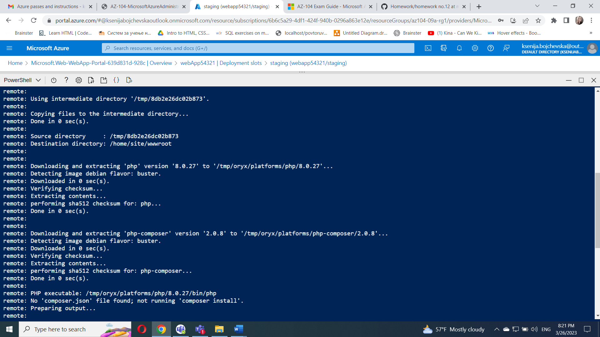

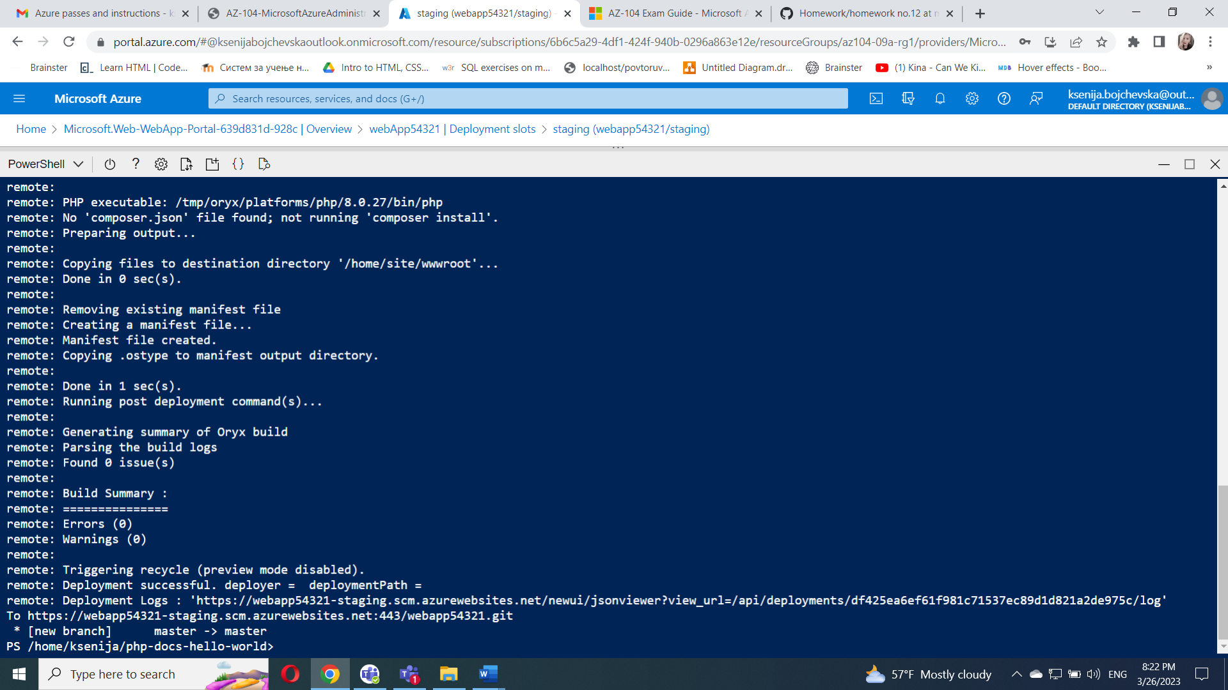

On the staging slot blade, click **Overview** and then click the **URL** link to display the default web page in a new browser tab.

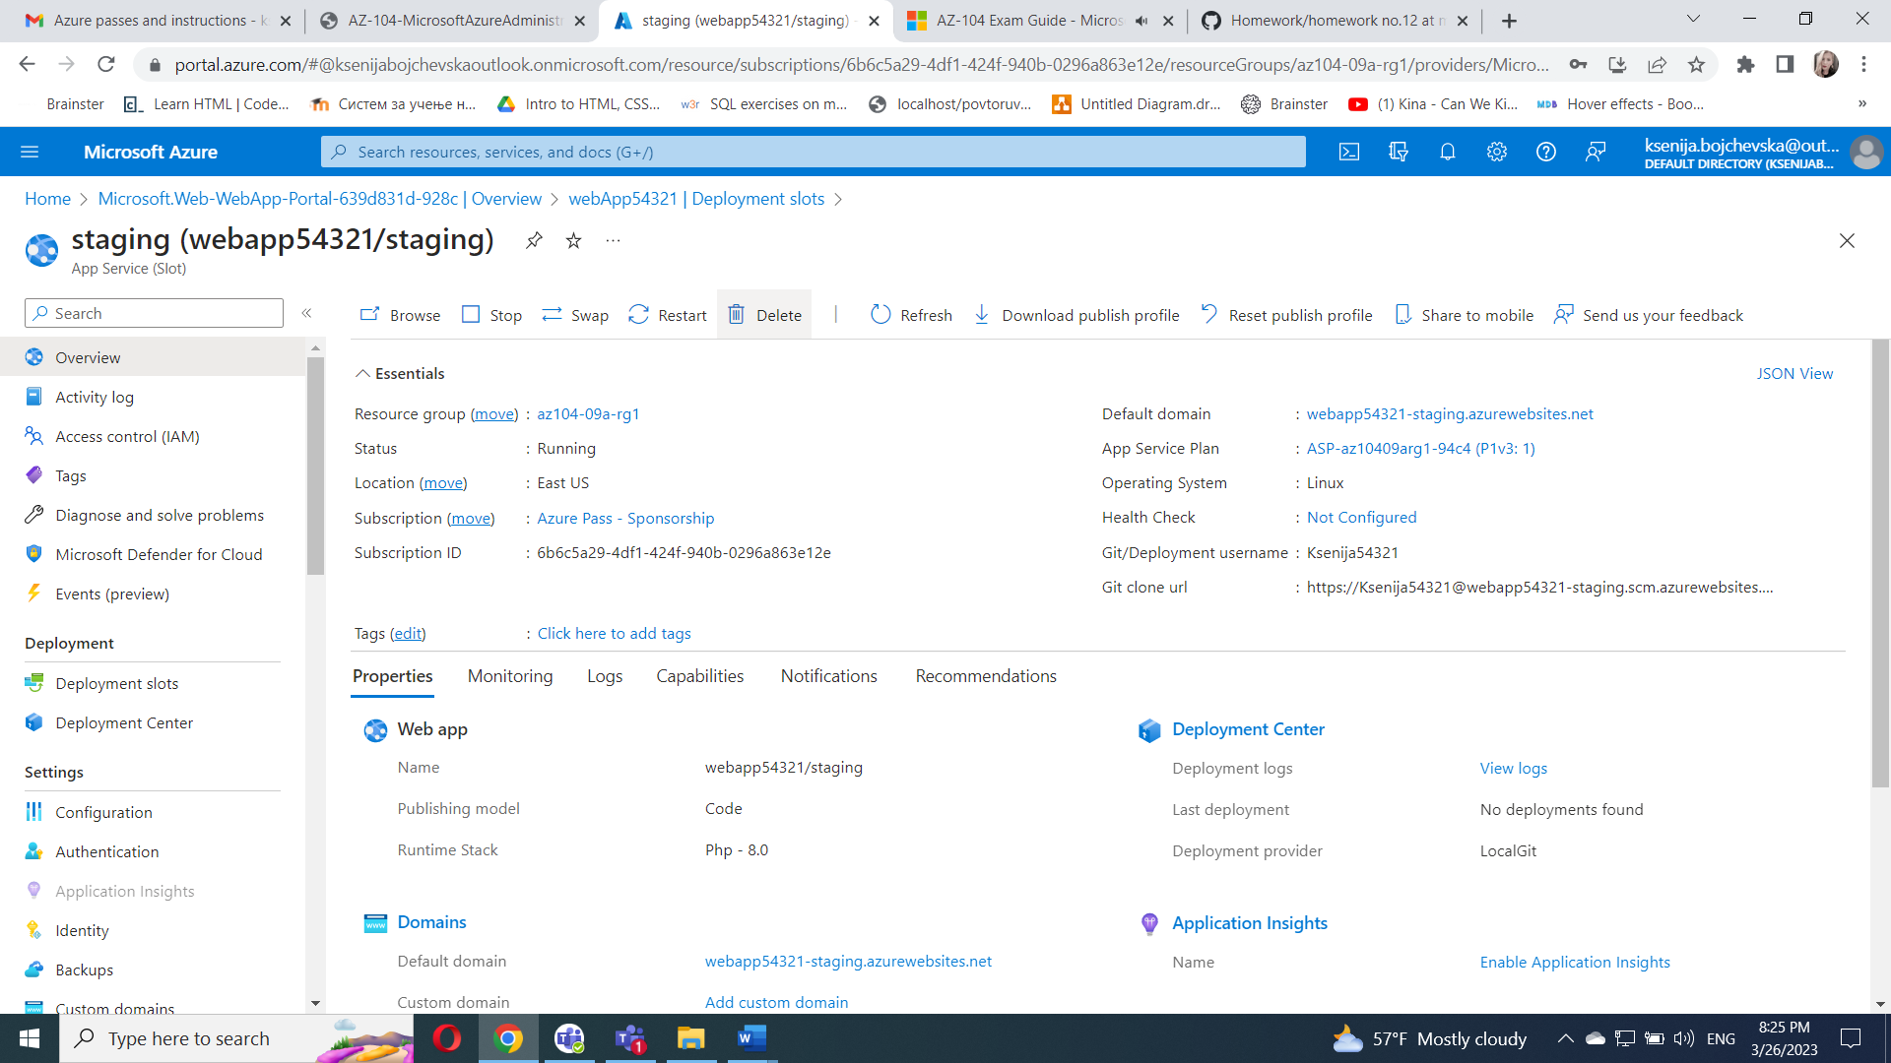

Verify that the browser page displays the **Hello World!** message and close the new tab.

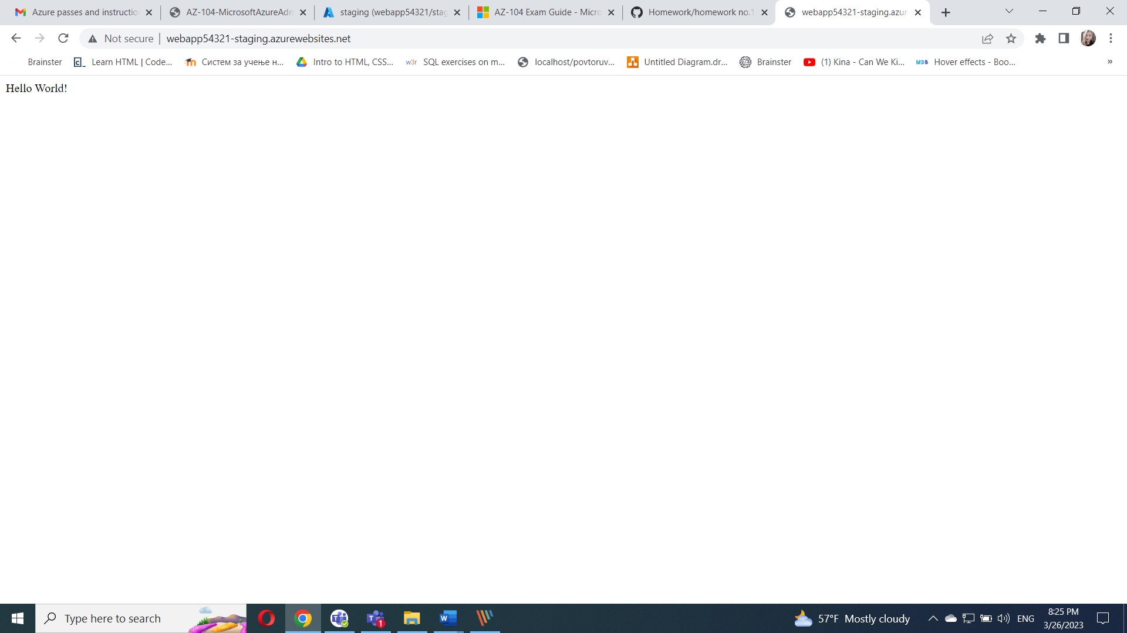

#### Task 5: Swap the staging slots

In the **Deployment** section, click **Deployment slots** and then, click **Swap** toolbar icon.

On the **Swap** blade, review the default settings and click **Swap**.

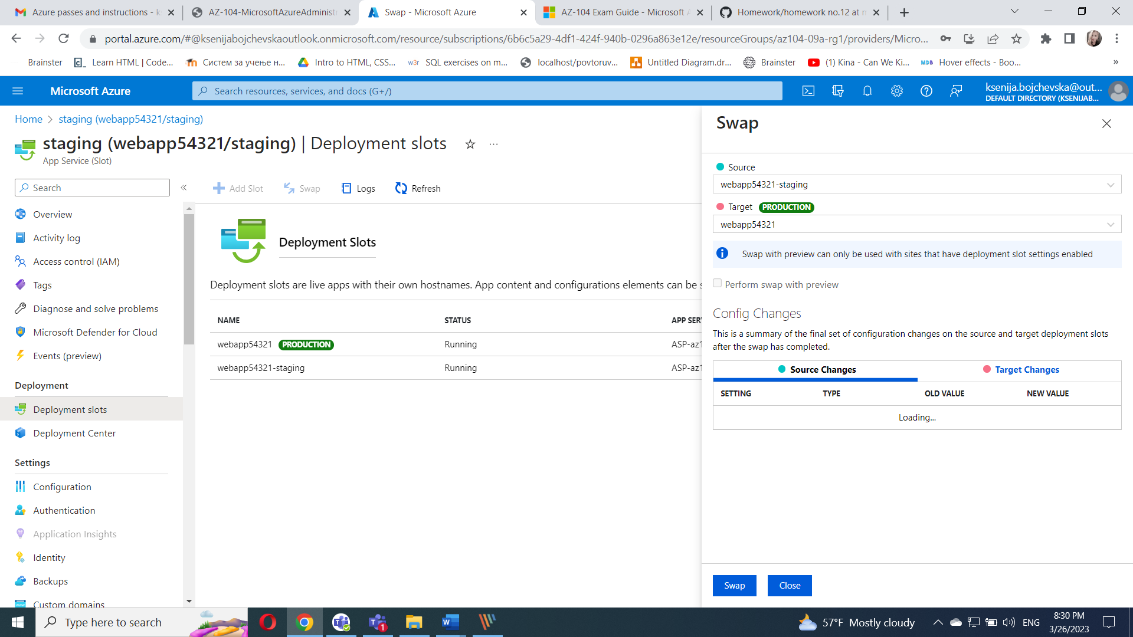

Click **Overview** on the production slot blade of the web app and then click the **URL** link to display the web site home page in a new browser tab.

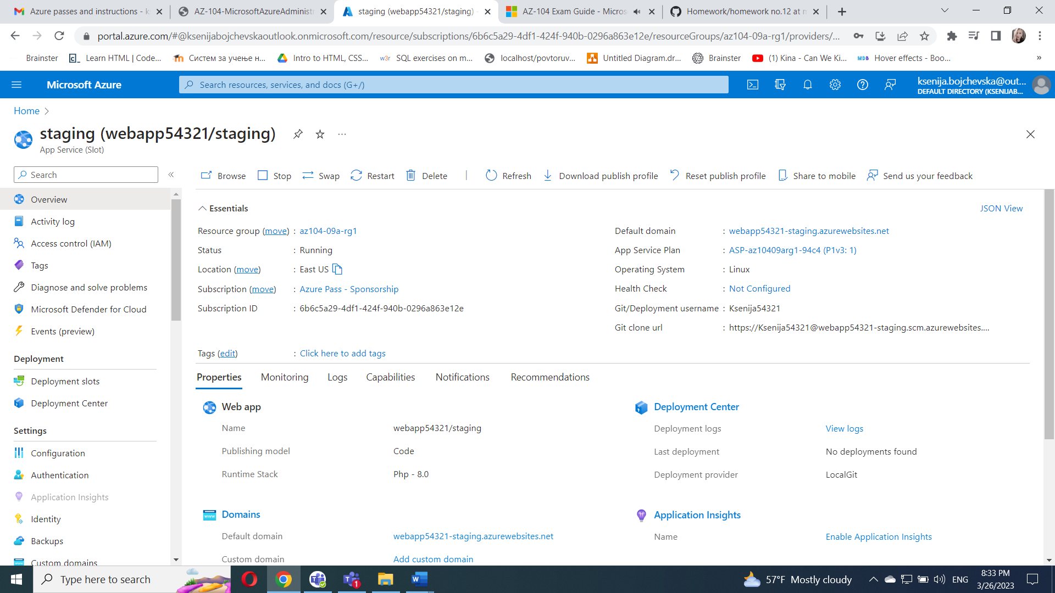

Verify the default web page has been replaced with the **Hello World!** page.

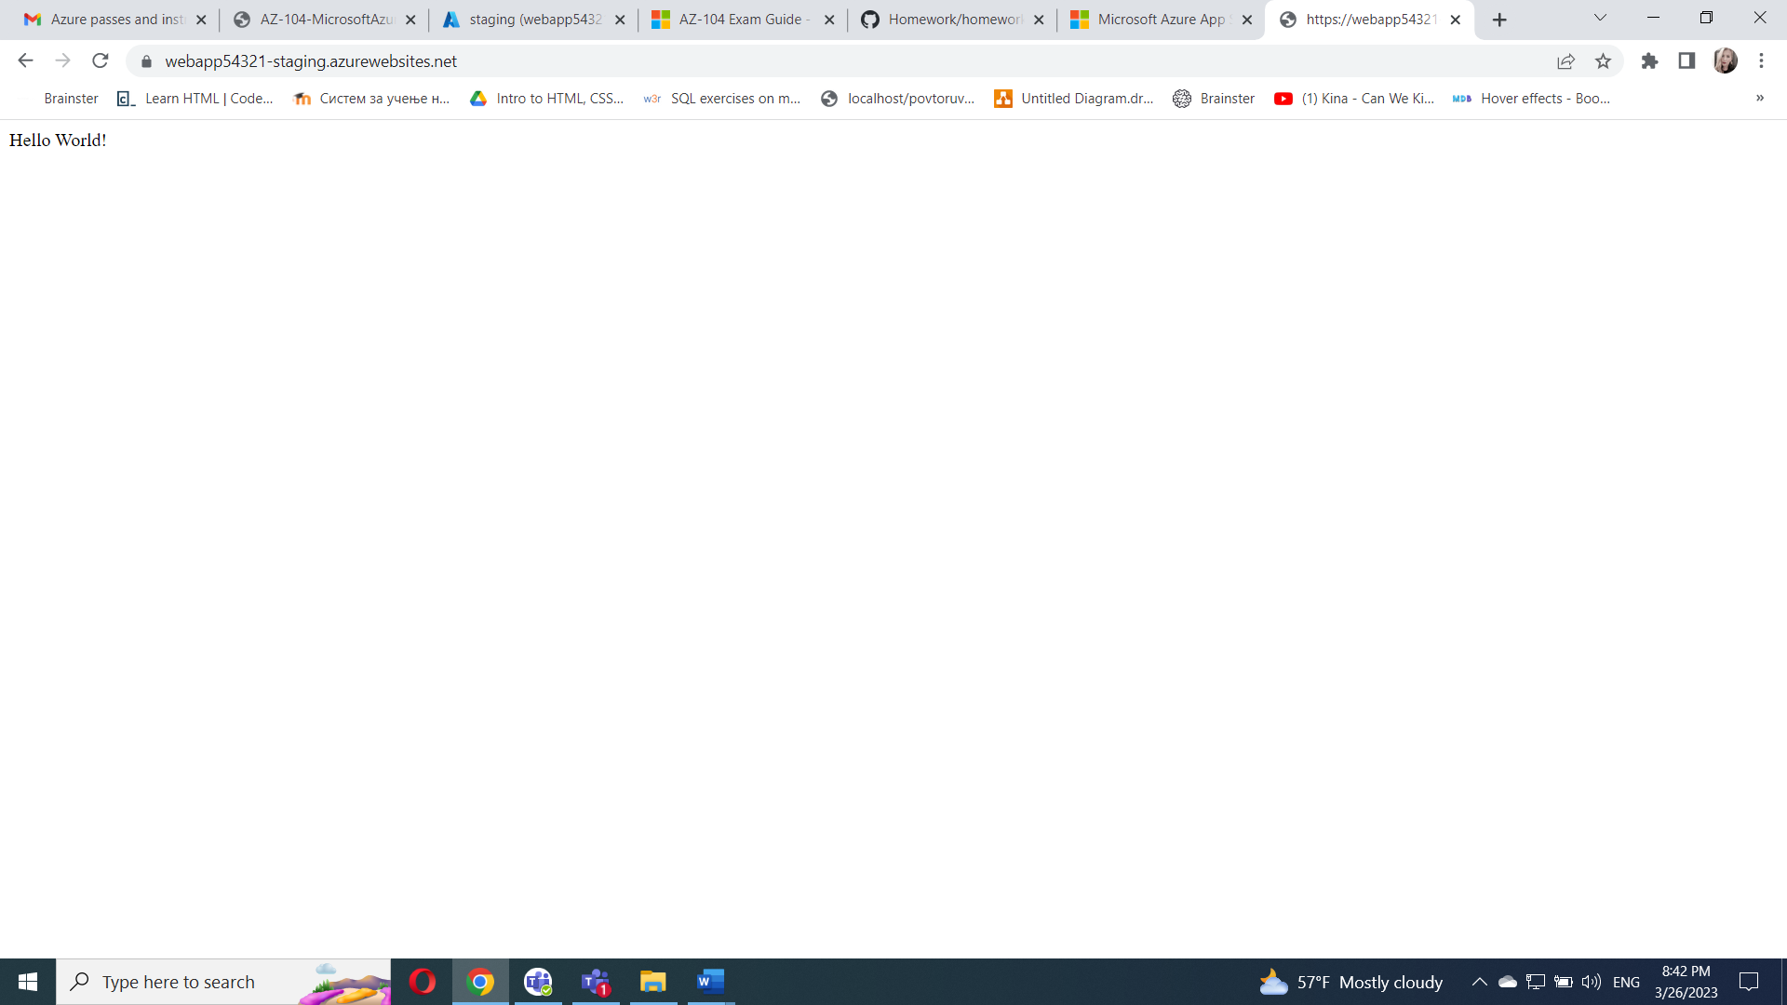

#### Task 6: Configure and test autoscaling of the Azure web app

In this task, you will configure and test autoscaling of Azure web app.

On the blade displaying the production slot of the web app, in the **Settings** section, click **Scale out (App Service plan)**.

Click **Custom autoscale**.

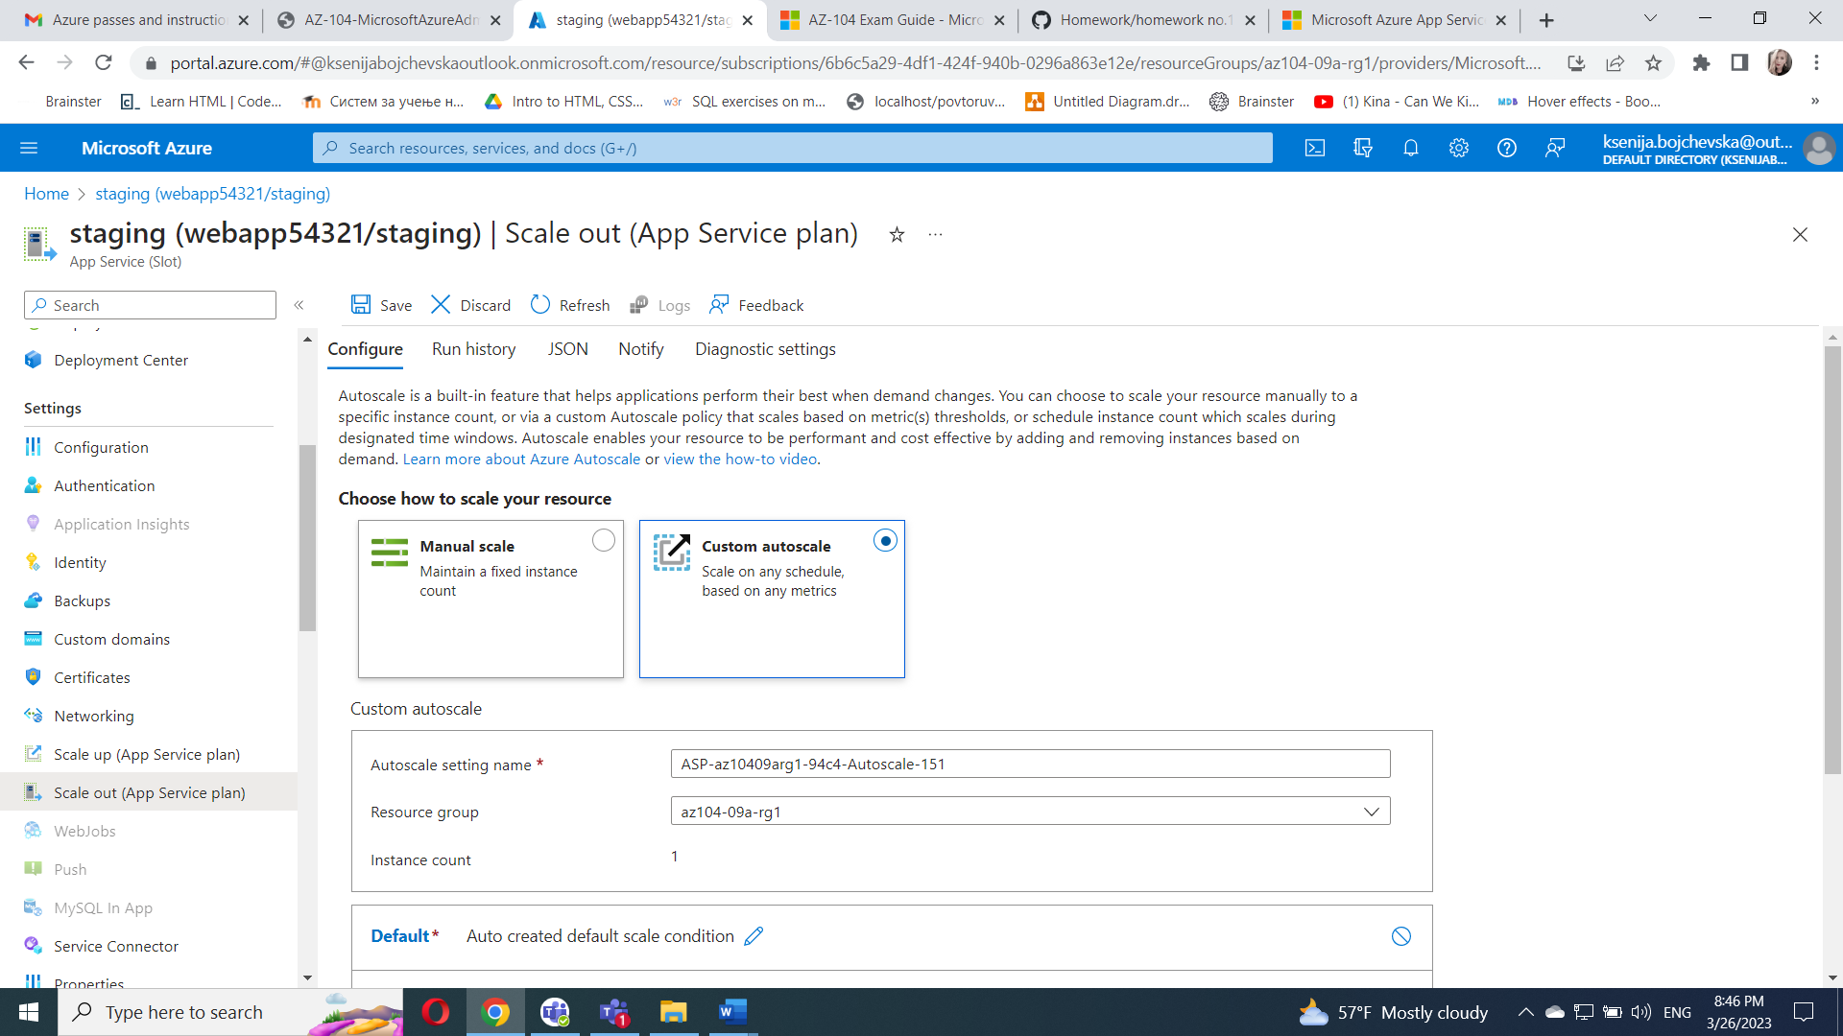

Select **Scale based on a metric** and click **+ Add a rule**

On the **Scale rule** blade, specify the following settings (leave others with their default values):

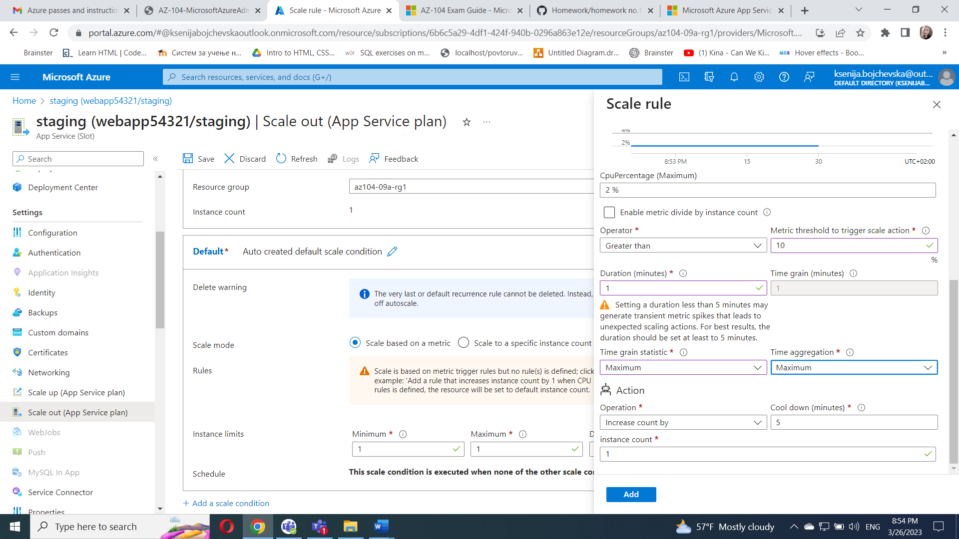

Click **Add** and, back on the App Service plan scaling blade, specify the following settings (leave others with their default values):

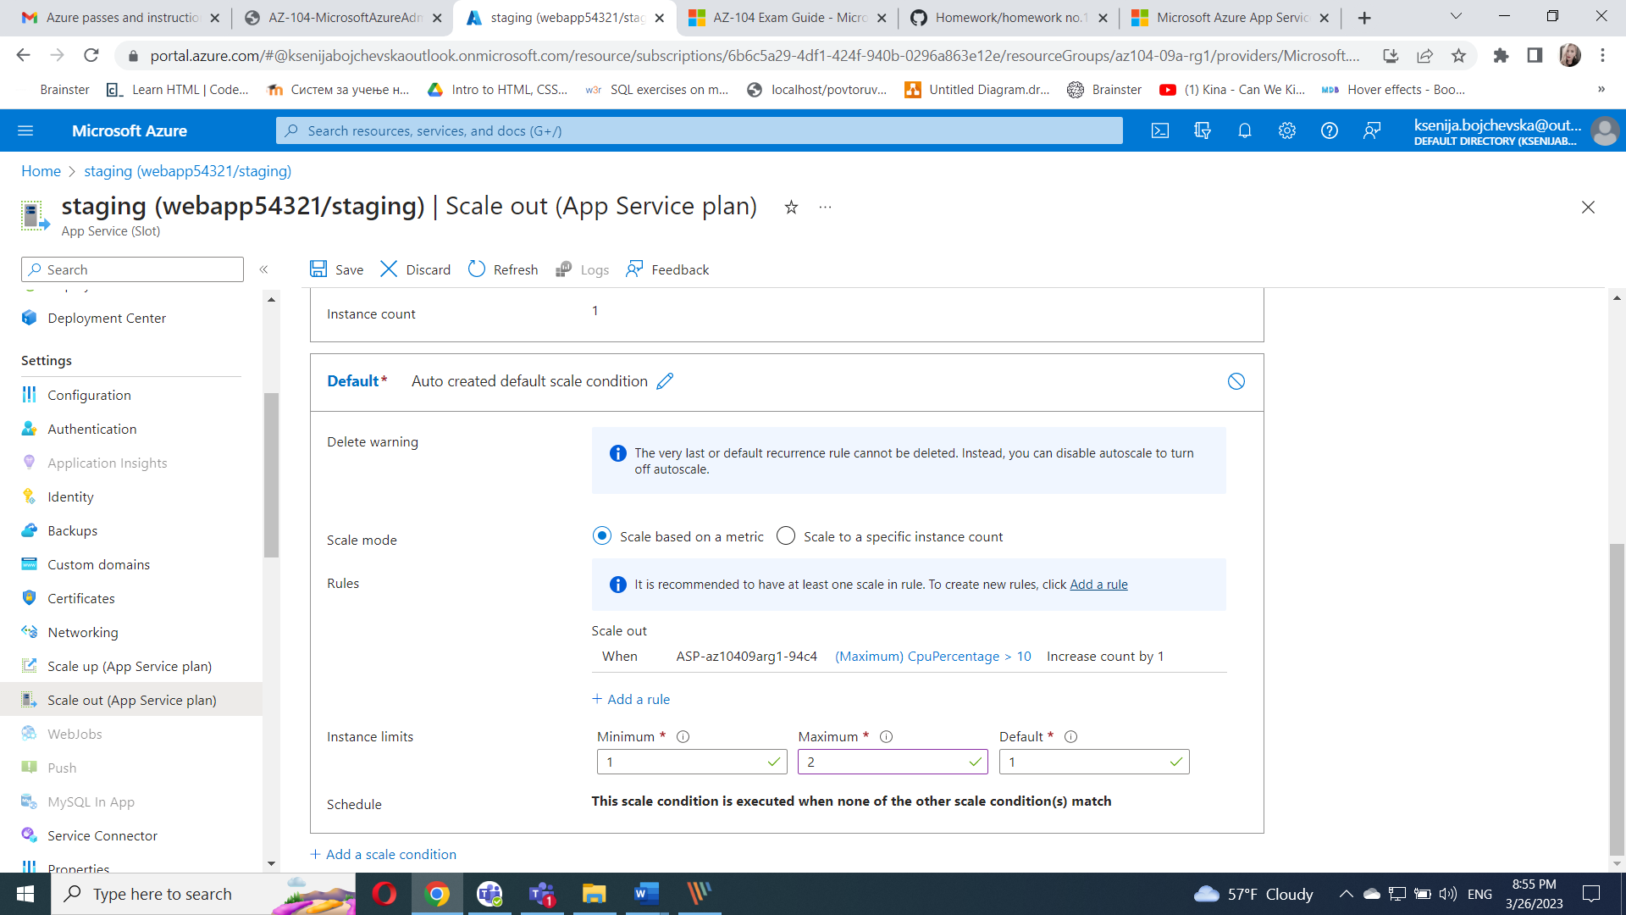

In the Azure portal, open the **Azure Cloud Shell** by clicking on the icon in the top right of the Azure Portal.

If prompted to select either **Bash** or **PowerShell**, select **PowerShell**.

From the Cloud Shell pane, run the following to identify the URL of the Azure web app.

$rgName = 'az104-09a-rg1'

$webapp = Get-AzWebApp -ResourceGroupName $rgName

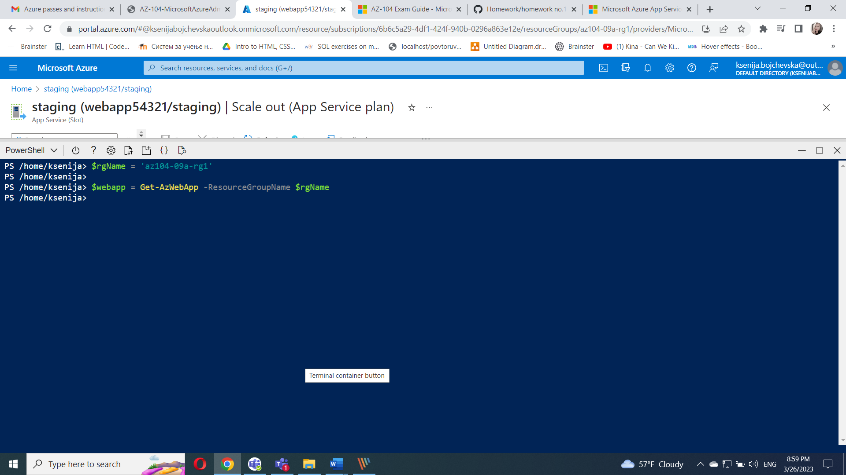

From the Cloud Shell pane, run the following to start and infinite loop that sends the HTTP requests to the web app:

while ($true) { Invoke-WebRequest -Uri $webapp.DefaultHostName }

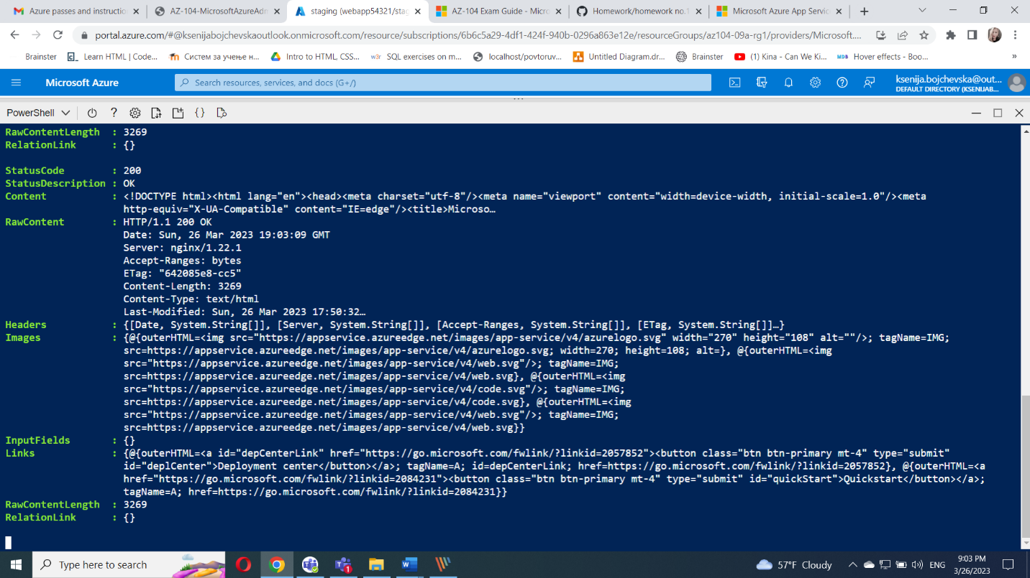

Minimize the Cloud Shell pane (but do not close it) and, on the web app blade, in the Settings section, click **Scale out (App Service plan)**.

Select the **Run history** tab, and check the **Observed resource instance count**.

Monitor the utilization and the number of instances for a few minutes.

Once you notice that the number of instances has increased to 2, reopen the Cloud Shell pane and terminate the script by pressing **Ctrl+C**.

